DATA CLEANING & DATA QUALITY VALIDATION REPORT
Disney movie DATASET
Microsoft Power BI – Power Query

PROJECT INFORMATION AND DETAILS:
NAME:BARANIDHARAN.S
FILE NAME:DISNEY MOVIE DATASET
TOOL USED:MICROSOFT POWER BI
DATA PREPARATION TOOL:POWER QUALITY EDITOR
REPORT TYPE:DATA CLEANING,VALIDATION AND QUALITY ASSURANCE

1. Project Overview
The Chocolate Industry dataset was reviewed and transformed using Microsoft Power BI Power Query. The purpose of the exercise was to identify data-quality problems and prepare the dataset for reliable business analysis and dashboard development.
Objectives
Identify invalid, missing, duplicate, inconsistent and incorrectly typed values.
Standardize text, categories, dates and numeric fields.
Apply business validation rules to important fields.
Document every transformation so the cleaning process is repeatable.
Validate the final dataset before loading it into the Power BI data model.
2. Dataset & Data Quality Review
Quality Dimension | What Was Checked | Expected Outcome
Completeness | Blank, null, NA and N/A values | Missing values handled appropriately
Accuracy | Invalid dates, prices, ratings and quantities | Invalid values corrected/removed after review
Consistency | Capitalization, spaces and category names | Standard representation
Uniqueness | Duplicate records | Duplicate transactions removed
Validity | Business rules and value ranges | Only valid values retained
Data Type | Date, whole number, decimal and text fields | Correct Power Query data types

3. Data Cleaning Operations & Detailed Procedures
3.1.IDENTIFYING DUPLICATES:
RIGHT CLICK OR GO TO GROUP BY AND CHECK THE COUNT OF THE THE COLUMNS IF IT IS MORE THAN 2 THEN IT IS DUPLICATE.
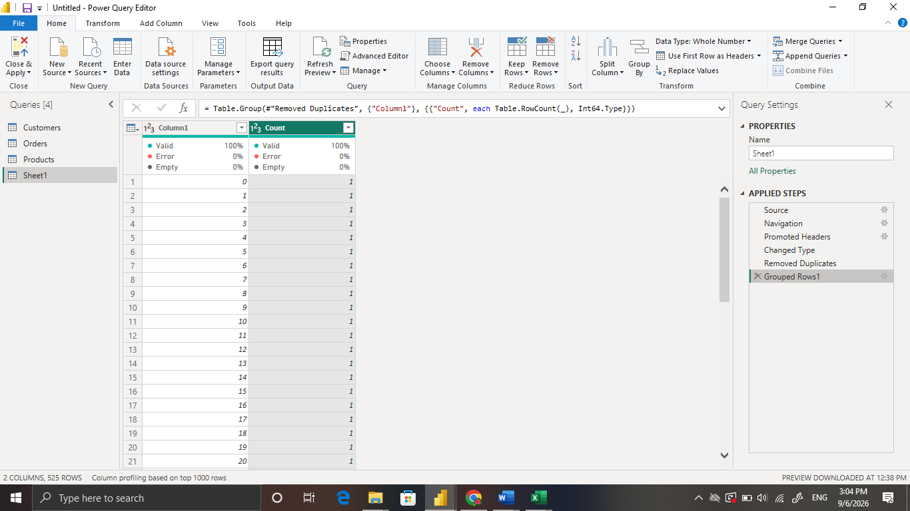

3.2.REMOVE DUPLICATES:

RIGHT CLICK AND GIVE THE REMOVE DUPLICATES.

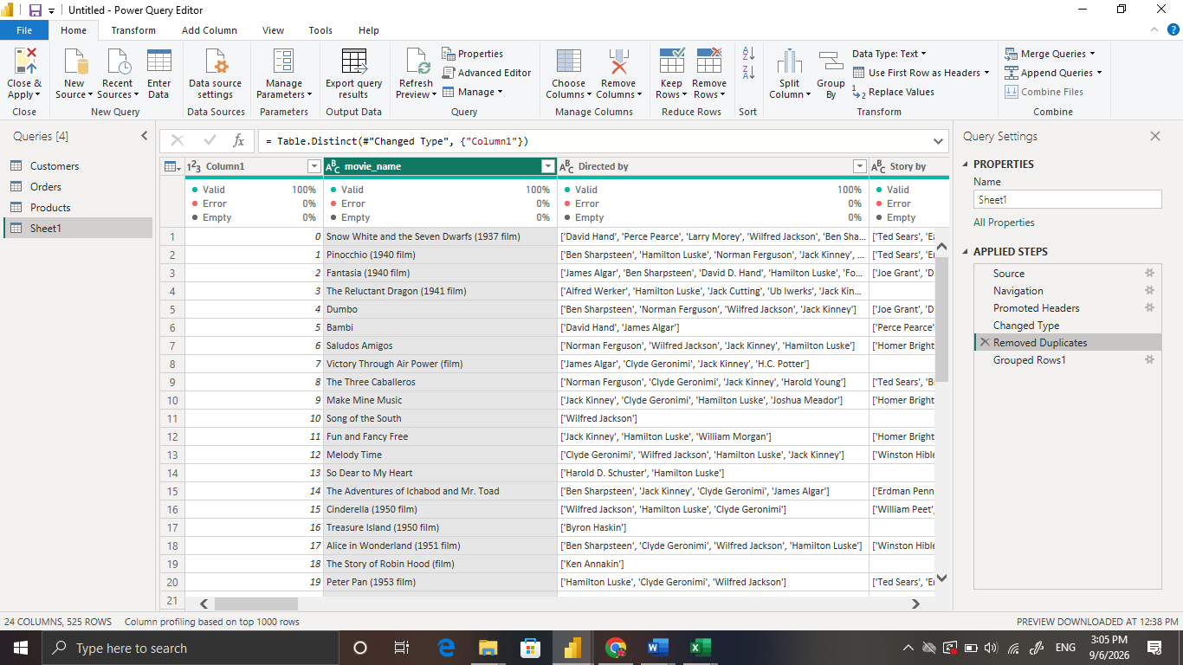

3.3.UPPERCASE:
GO TO THE TRANSFORM AND SELECT THE UPPERCASE TO CAPITALIZE EACH LETTER.

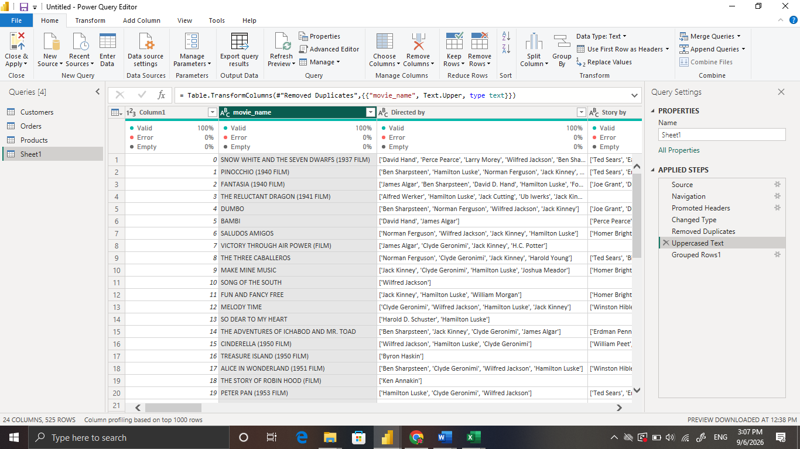

3.4.LOWER CASE:

GO TO THE TRANSFORM OPTION AND GIVE LOWERCASE ICON AND TO WRITE IN LOWERCASE EACH LETTER.

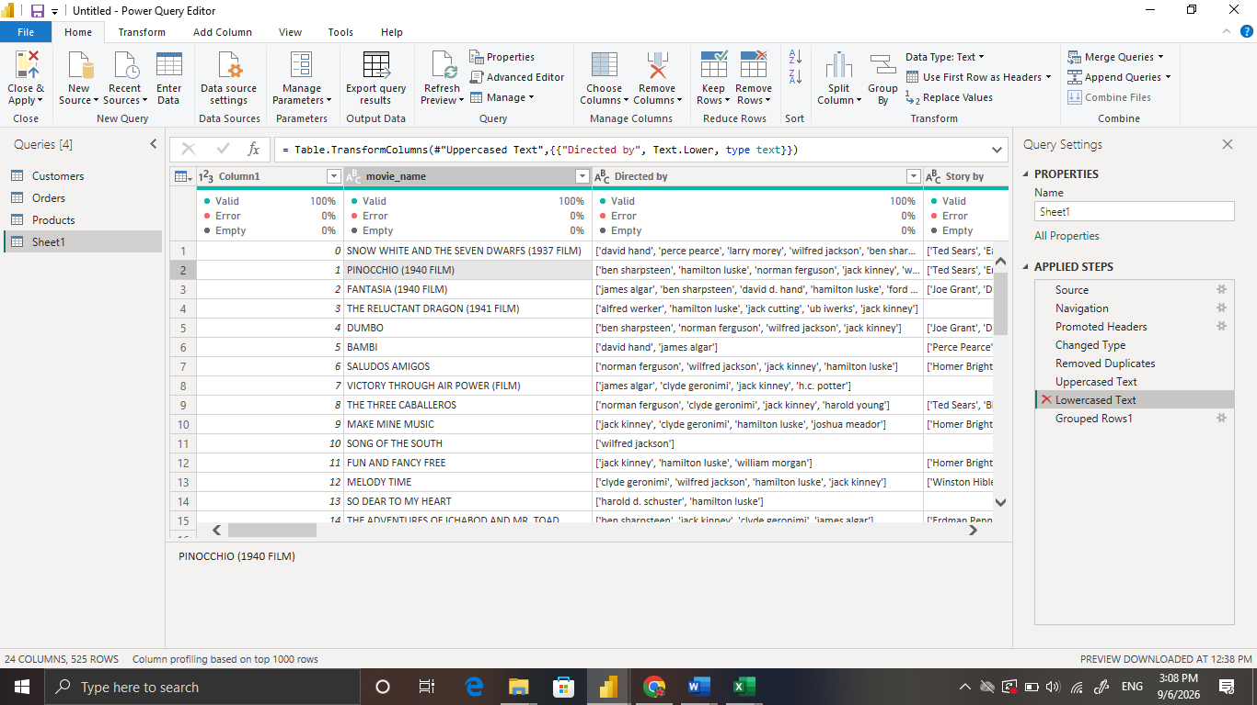

3.5.CAPITALIZE EACH WORD:

GO TO THE TRANSFORM AND CHOOSE THE CAPITALIZE EACH WORD IT MEANS IT GIVES UPPERCASE TO EACH WORD’S FIRST LETTER.
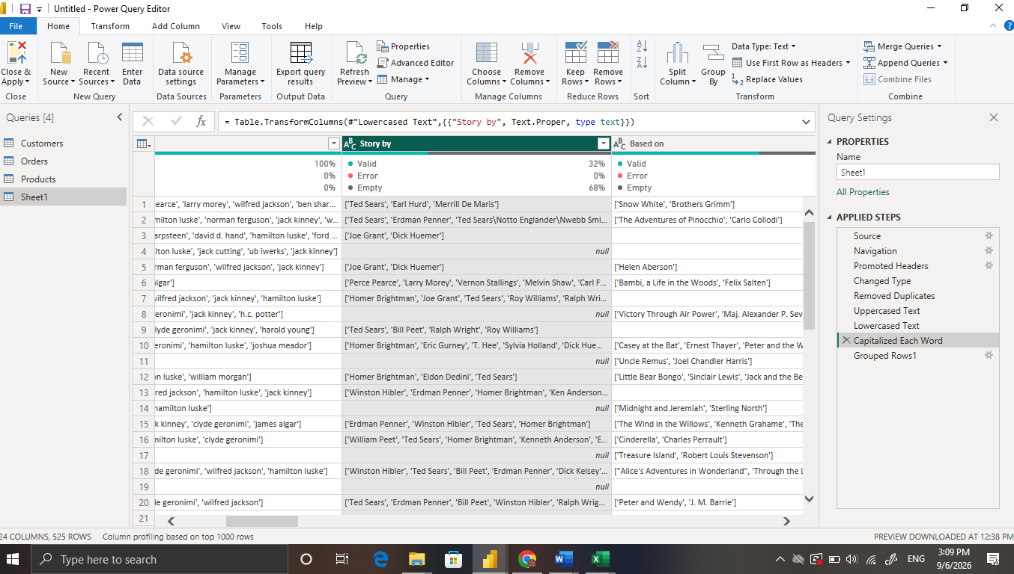

3.6.REPLACE NULL BY N/A:
SELECT THE TITLE RIGHT CLICK THEN REPLACE VALUES FOR EXAMPLE NULL BY CHANGING N/A.
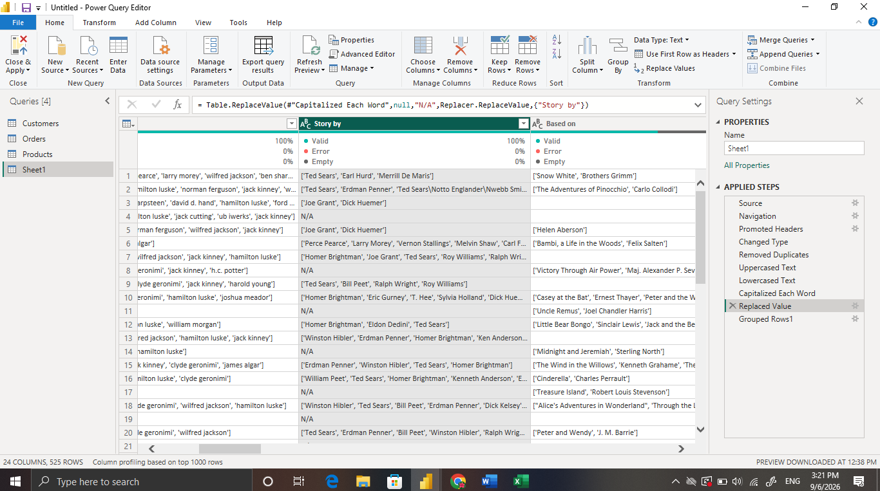

3.7.Rename:

DOUBLE CLICK ON THDE TITLE BAR THEN CHANGE THE COLUMN NAME.

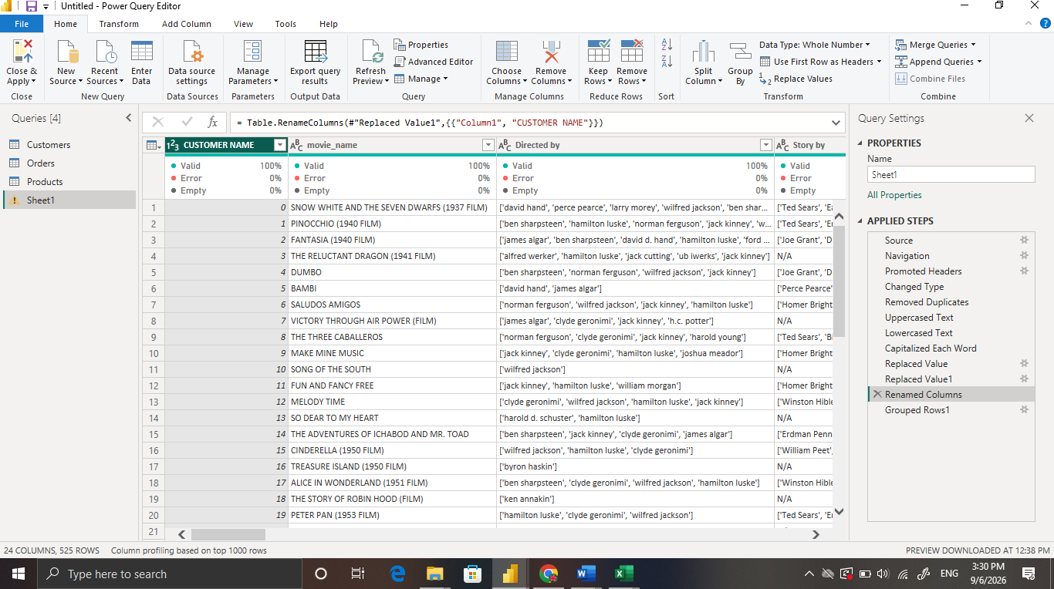

3.8. TRANSPOSE ROWS INTO CLOUMNS:

GO TO THE TRANSFORM SECTION AND GIVE TRANSFORM THEN IT WILL CHANGE ROWS INTO COLUMN.

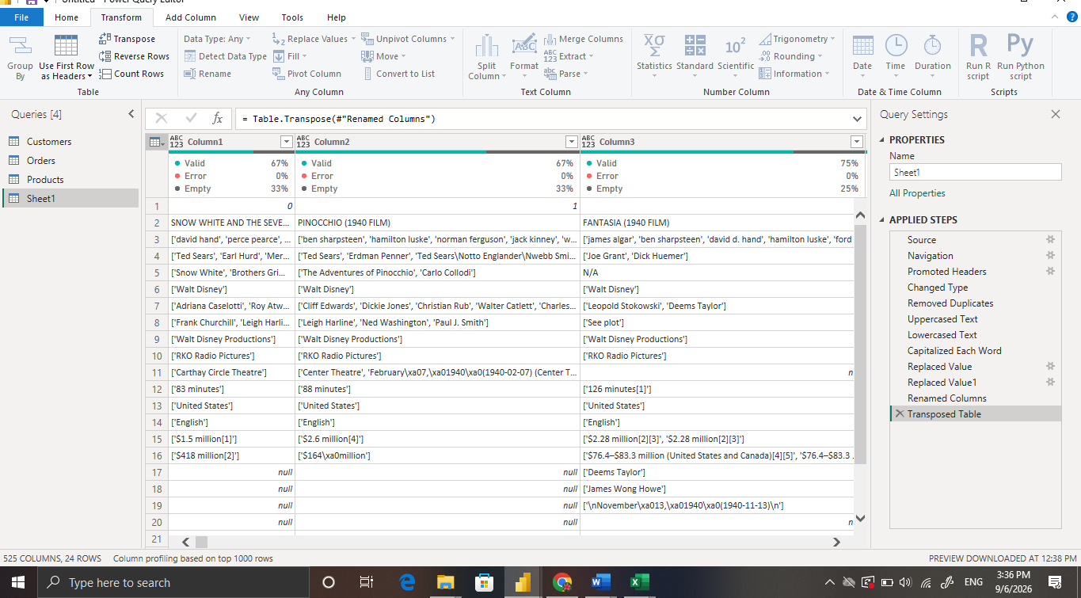

3.9.transpose Columns into Rows:

GIVE THE SAMEWAY AS ROWS INTO COLUMN.
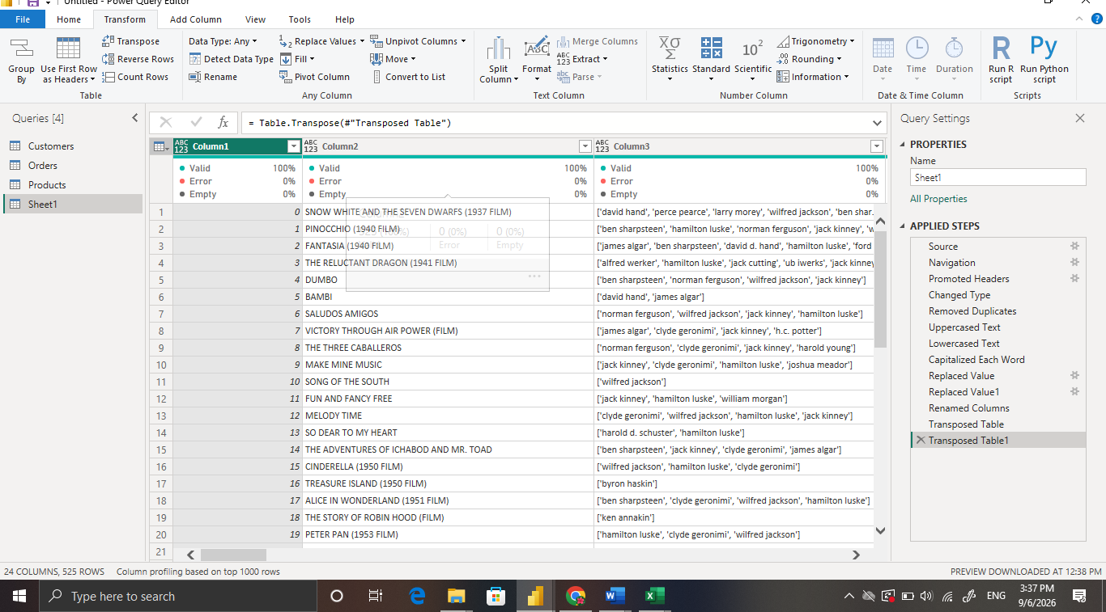

3.10.Remove columns:

CLICK ON THE TITLE BAR THEN THER IS A REMOVE ICON.THEN IT WILL REMOVE THE SPECIFIC COLUMN.
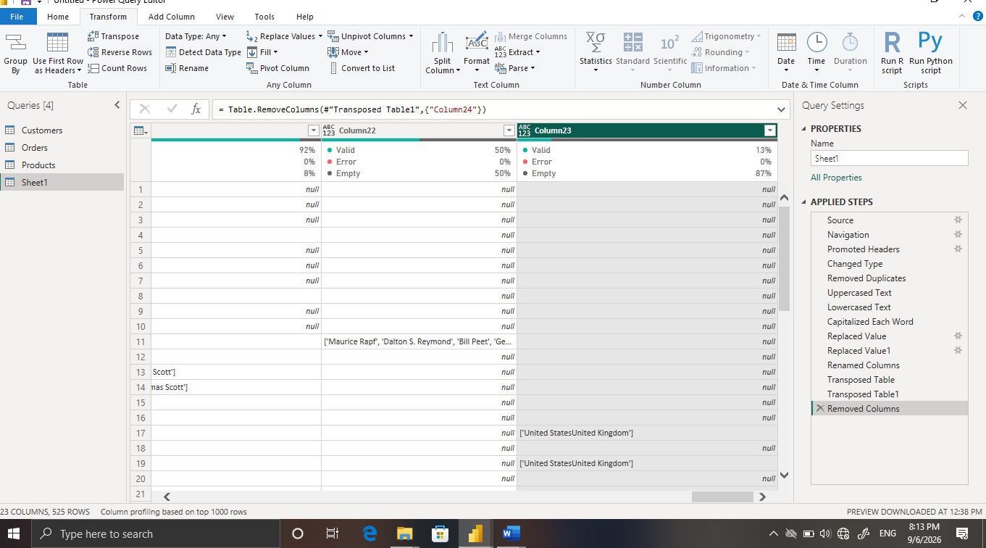

3.11.To find the length of the word:

IN THE TRANSFORM SECTION THERE IS A EXTRACT OPTION .IN THAT WE GIVE LENTH That MEANS IT WILL GIVE LENGTH OF THE WORD.

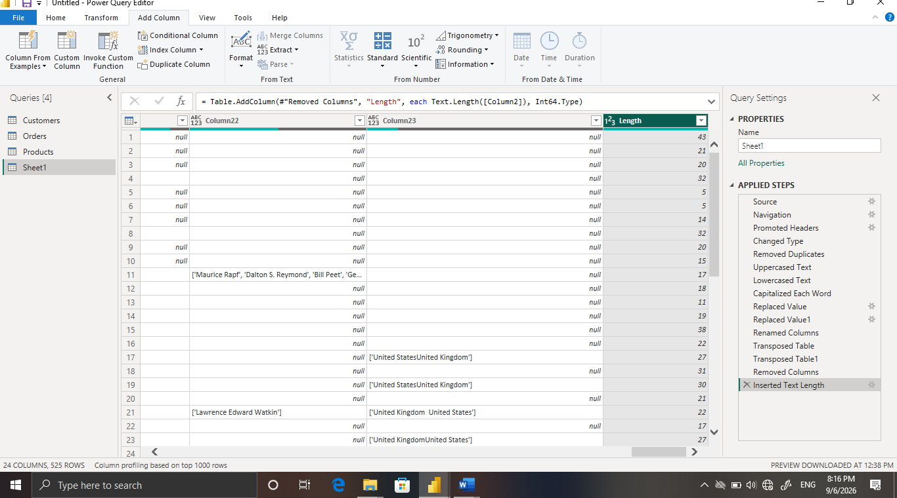

3.12.To find the maximum values:

IN TRANSFORM SECTION THERE IS A STATISTICS.IN THAT WE WILL GIVE MAXIMUM FOR FINDING MAXIMUM VALUE.

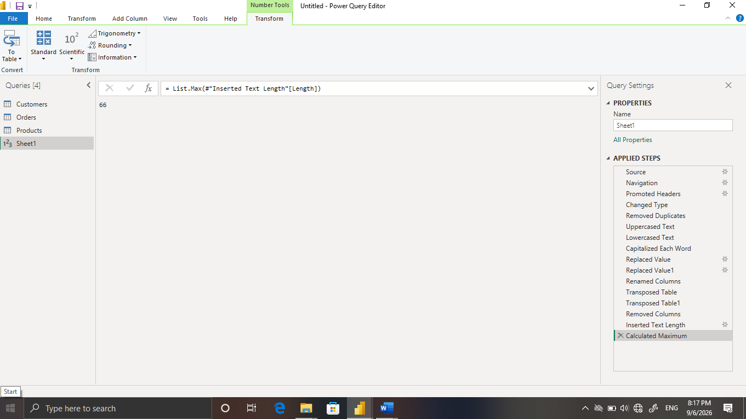

3.13.To find the minimum value:

IN TRANSFORM SECTION THERE IS A STATISTICS.IN THAT WE WILL GIVE MINIMUM FOR FINDING MINIMUM VALUE.

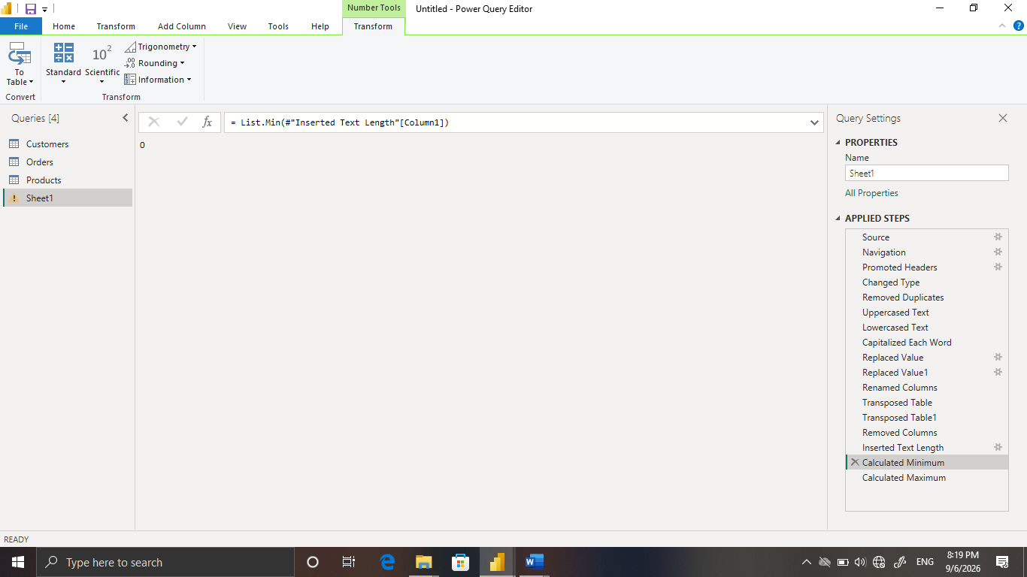

3.14.Average:

IN TRANSFORM SECTION THERE IS A STATISTICS.IN THAT WE WILL GIVE AVERAGE FOR FINDING AVERAGE VALUE.

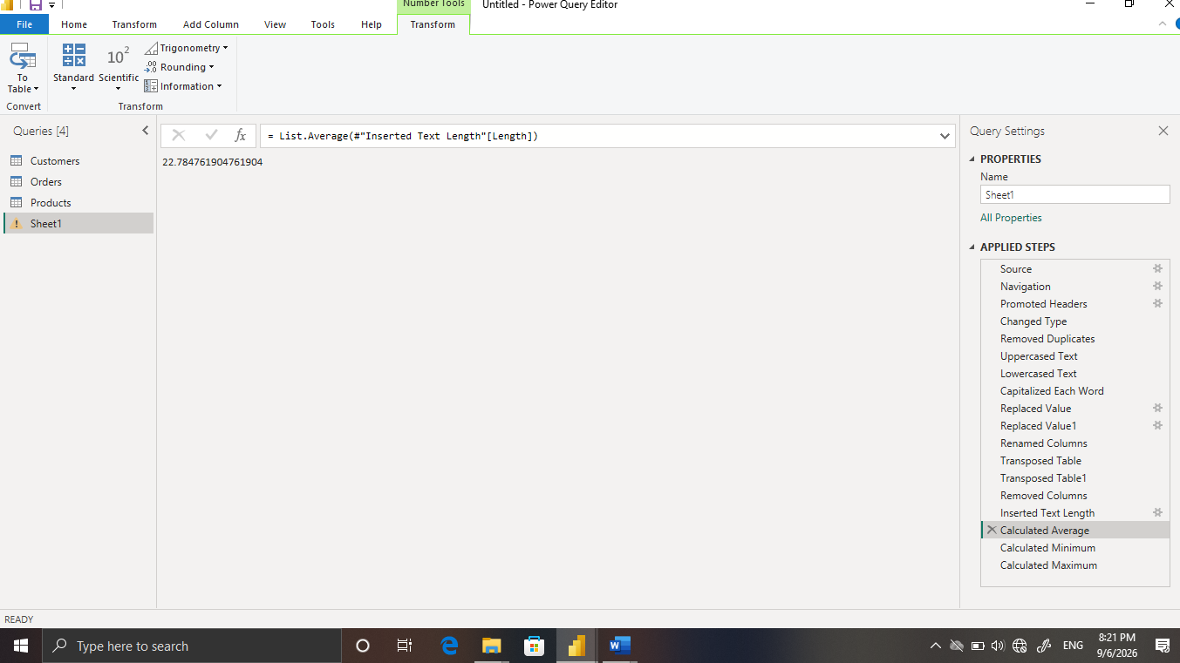

3.15.Sorting it in ascending order:

CLICK IN LEFT SIDE OF THE TITLE BAR.THERE IS SORTING OPTION.

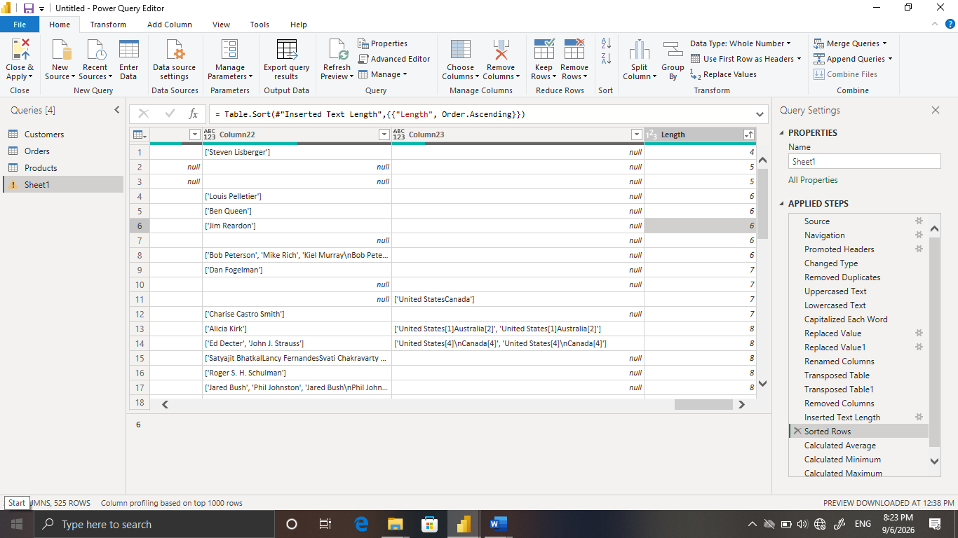

3.16.Column quality checking:

IN THE VIEW SECTION THERE IS A QUALITY CHECKING IT WILL SHOW THE ERROR IN THE DATASET.

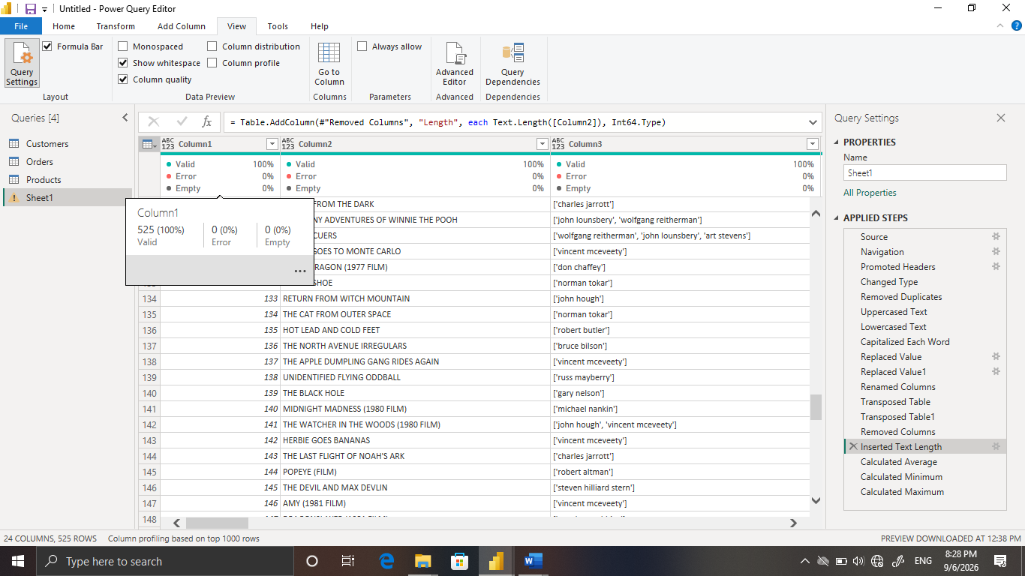

3.17.Rows count:

IN TRANSFORM SECTION THERE IS ROWS COUNT IT WILL COUNT THE TOTAL ROWS .

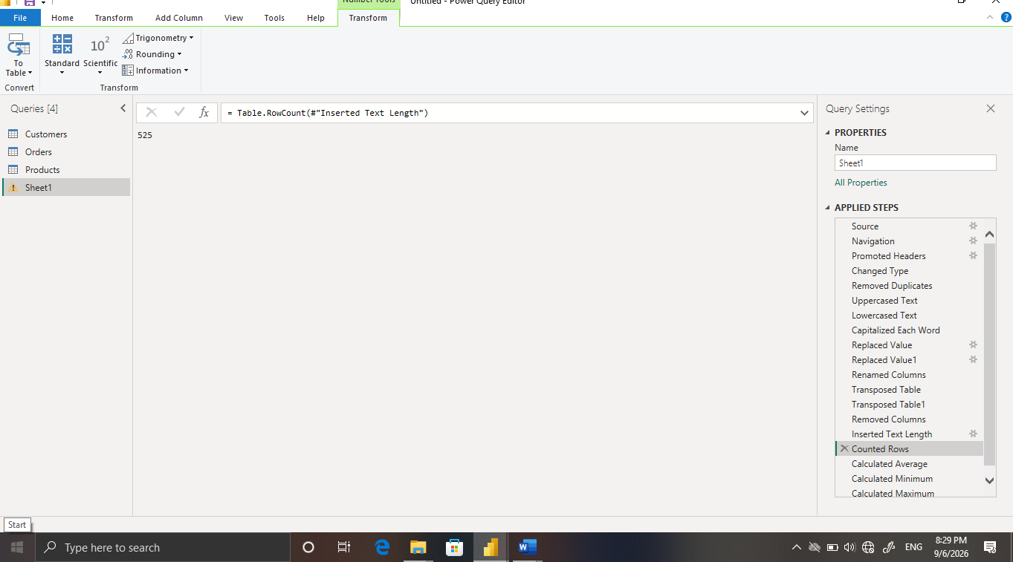

4. 4. Business Validation Rules
Field | Validation Rule | Reason | Action if Invalid
CUSTOMER | Should be unique | Avoid duplicate transaction identifiers | Investigate/remove duplicate after verification
Movie name | Valid date; expected business period | Accurate time analysis | Correct or remove invalid record
Directed by | Should not be blank where required | Product analysis | Replace/flag or remove according to rule
Category | Must match approved categories | Reliable grouping | Standardize using Replace Values
Budget | ≥ 0 and numeric | Prevent invalid sales values | Investigate/correct/filter
Quantity | > 0 where an order must contain quantity | Prevent impossible quantities | Investigate/correct/filter
Rating | 1–5 if 5-point scale is defined | Valid customer-rating analysis | Flag/filter invalid values
5. Issue-to-Solution Matrix
Issue | Detection Method | Power Query Operation | Final Status
Missing / NA values | Column Quality / filter | Replace Values / Remove Rows | Resolved
Extra spaces | Visual inspection / distinct values | Trim | Resolved
Hidden characters | Text inspection | Clean | Resolved
Inconsistent capitalization | Column Distribution | Format case | Resolved
Category variations | Distinct values | Replace Values | Resolved
Incorrect numeric type | Data type icon | Change Data Type | Resolved
Invalid rating range | Filter / profile | Number validation | Resolved
Invalid Running time | Filter / profile | Number validation | Resolved
Duplicate records | Duplicate check | Remove Duplicates | Resolved

6. Before vs After Data Quality Summary
Area | Before Cleaning | Operation Applied | After Cleaning
Headers | Generic/unclear | Promote Headers | Meaningful headers
Text | Spaces/inconsistent case | Trim, Clean, Format | Standardized text
Missing values | Null/NA/blank values | Replace/Remove as justified | Controlled missing values
Null values | Invalid/error values | Date type + Remove Errors | Valid date field
Numbers | Incorrect types | Change Data Type | Analysis-ready numeric fields
Categories | Multiple representations | Replace Values | Standardized categories
Duplicates | Repeated records | Remove Duplicates | Cleaner unique records
Validation | Not documented | Business rules + profiles | Validated dataset

7. Screenshot Documentation Plan
For a high-standard submission, insert actual Power Query screenshots at each placeholder above. Each screenshot should show the relevant column, transformation menu or Applied Steps pane. Avoid screenshots that contain unrelated personal information.

8. Final Quality Checklist
Check | Status | Evidence
Headers promoted | Completed | Applied Steps / screenshot
Text trimmed and cleaned | Completed | Transform steps
Missing values reviewed | Completed | Replacement/filter step
Categories standardized | Completed | Replace Values
Dates corrected | Completed | Date type + error handling
Numeric types corrected | Completed | Data type icons
Price validated | Completed | Numeric rule
Rating validated | Completed | 1–5 rule if applicable
Quantity validated | Completed | >0 rule if applicable
Duplicates removed | Completed | Remove Duplicates
Column Quality reviewed | Completed | Quality profile
Final output validated | Completed | Final screenshot

9. Conclusion
The Disney dataset was cleaned and validated using Microsoft Power BI Power Query. The process addressed data completeness, consistency, validity, uniqueness and data-type quality. The documented transformations create a repeatable preparation workflow and provide a stronger foundation for subsequent data modelling, DAX measures, KPI development and dashboard reporting.
10. Final Result
DATA CLEANING COMPLETED

